
DA Software Solutions (Pvt.) Limited.
#76, Pagoda Road, Nugegoda. Sri Lanka.
E-mail: dumindu@dassonline.com
Phone: +94 114 941 921, +94 773 435 429

01st January 2010

Mr. Rasika S. Karadawa
IT Administrator,
Lake house printers & Publishers,
Colombo 02

Dear Sir,

QUOTATION for "Seylan Bank Data-Separation and report Printing” Software Solution

First and foremost, thank you very much for your interest in DA Software Solutions (Pvt) Ltd. With reference to your inquiry on the above software solution, we are pleased to submit herewith our price quotation for your kind consideration.

Pricing Summary

Data-Separation Software - design & development Rs. 85,000.00

4 No. of New Report- design & development Rs. 40,000.00

Total Rs. 1,25,000.00

10% Special Discount for Lake house printers & Publishers RS. (12,500.00)

Total cost of software solution Rs. 112,500.00

Currency of Offer
All prices are in Sri Lankan Rupees.

Proposal Validity
This proposal is valid for a period of one (01) month.

Payment Terms & Other Charges

Application System Charges
50% - on confirmation of the quotation
50% - on completions prior to hosting
Software Warranty
This software solution carries a warranty period of three (03) months from the date of User acceptance test (UAT).

Software Maintenance
Maintenance services shall be provided under a maintenance agreement to be signed after the warranty period expires. The standard annual maintenance charges would be fifteen percent (15%) on the product price plus the subsequent cost of modifications.
Software Maintenance
Upfront 100% maintenance fees for a period of one year at the signing of the maintenance contract.
During such annual maintenance DASS shall rectify all software related faults, defects and malfunctions free of charge.

Additional Software Modifications
All additional software modification charges will be quoted after a detailed system study. The development of the modifications would begin once a written confirmation is given by the client.

Modification Charges
Rs. 8,000 - Per Man day
50% - on confirmation of the quotation
50% - on implementation of the modifications

Updates/New Modules
Customers under maintenance service agreement are entitled to free Application Updates within the same version, database, operating system, and application language (subject to application customizations done at the client’s site) of the modules purchased.
Other additional/new modules/new version upgrades would be available at a very special discounted price to your company.

Purchase Order & the Payments
Purchase Order and the payments to be issued to “DA Software Solutions (Pvt) Ltd.”

Confidentiality
All material, prices and other information’s provided in this proposal and other supporting documents, annexure, CD-ROMs, diskettes etc. should not to be disclosed to any 3rd party without written consent.

We hope this pricing proposal would meet your requirements. Should you need any further clarifications, please feel free to contact us.

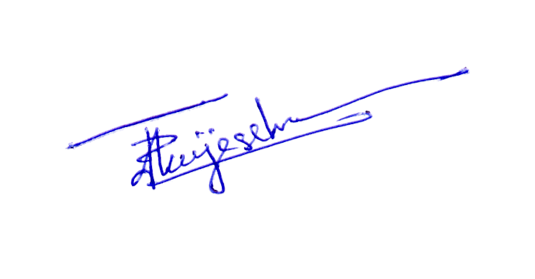
Thank You,
Yours sincerely,

D. Janeendranath Wijesekera
Director Business Development

